Model Evaluation with Cross-Validation and Random Forest

Abstract
Evaluating machine learning models is essential to ensure they generalize well to unseen data. Simple train-test splits often provide misleading results due to data imbalance or randomness. This project applies two widely used validation methods—K-Fold Cross-Validation and Stratified K-Fold Cross-Validation—to evaluate classification models reliably. The primary focus is on the Random Forest classifier, an ensemble technique that combines multiple decision trees to reduce overfitting and improve accuracy. The Random Forest model is compared with two additional models: Support Vector Machine (SVM) and Decision Tree. Hyperparameter tuning is performed using GridSearchCV to obtain the best-performing Random Forest configuration.
The Breast Cancer Wisconsin Diagnostic Dataset is used in this study. Evaluation is performed using accuracy, precision, recall, F1-score, ROC curve, and confusion matrix. A final visual comparison using a horizontal bar chart provides a clear comparison of model performance. Experimental results reveal that SVM achieves the highest mean cross-validation accuracy, Random Forest performs very strongly after tuning, and Decision Tree—while simple—tends to overfit. The project demonstrates a complete end-to-end workflow of preprocessing, modeling, validation, tuning, evaluation, and visualization.

Introduction
Model evaluation is a crucial step in any machine learning workflow. Without proper validation, a model may show high accuracy on training data but fail completely when exposed to real-world data. Overfitting is one of the major concerns when developing predictive models, particularly in medical datasets where class imbalance is common.
Cross-validation provides a robust mechanism for assessing how well a model performs on unseen data. In classification problems, especially with imbalanced classes, Stratified K-Fold Cross-Validation becomes more reliable than simple K-Fold because it preserves the class distribution across folds.
Random Forest, a widely used ensemble method, improves accuracy by combining multiple decision trees using bagging. Compared to a single Decision Tree, it significantly reduces overfitting. On the other hand, Support Vector Machines (SVM) are powerful classifiers known for strong performance on high-dimensional datasets.
This project aims to evaluate these three models using robust cross-validation techniques and determine which model performs best for the diagnosis prediction task.

Problem Statement
Evaluating the performance of machine learning models is critical to ensuring their robustness and generalization ability. Traditional train-test splits do not provide reliable performance estimates, especially when datasets are small or imbalanced. Cross-validation techniques such as K-Fold Cross-Validation and Stratified K-Fold ensure that models are evaluated fairly and consistently.
Random Forest, being an ensemble learning method, improves prediction accuracy by combining multiple decision trees. This project focuses on applying cross-validation techniques and Random Forest to evaluate and compare model performance.

Dataset Description
Since no dataset is explicitly provided, a standard Kaggle/scikit-learn dataset is used.
Dataset Used : Breast Cancer Wisconsin Diagnostic Dataset
Target Variable
- diagnosis
  - M → Malignant (1)
  - B → Benign (0)

Features
30 numerical features describing:
- radius, texture, perimeter
- area, smoothness
- compactness, concavity
- symmetry, fractal dimension
- worst/mean values, etc.
Dataset Size
- 569 rows
- 33 columns
Preprocessing performed
- Dropped unnecessary columns: id, Unnamed: 32
- Converted diagnosis labels (M/B → 1/0)
- Checked for missing values (none found)
- Feature scaling performed for SVM using StandardScaler

Preprocessing Code Summary
Data Loading
The dataset was imported from a CSV file containing 569 samples with 33 columns, including feature values and diagnosis labels.
Column Removal
Two non-essential columns were removed:
- id — used only for identification
- Unnamed: 32 — an empty column with no values
Label Conversion
The diagnosis column, which originally contained the labels:
- "M" for Malignant
- "B" for Benign
was converted into numerical format:
- 1 → Malignant
- 0 → Benign
Feature & Target Separation
All feature columns were grouped into a feature matrix (X), and the diagnosis column was used as the target variable (y).

Cross-Validation Techniques
K-Fold Cross-Validation
K-Fold divides the dataset into K equal parts. Each time:
- K−1 folds are used for training
- The remaining fold is used for testing
This process runs K times to compute average performance.
Results
K-Fold Accuracy Scores:
[0.9649, 0.9649, 0.9386, 0.9649, 0.9646]

Mean Accuracy: 0.9596

Stratified K-Fold Cross-Validation
Stratified K-Fold maintains the same class distribution in each fold.
Results
Stratified K-Fold Accuracy Scores:
[0.9649, 0.9386, 0.9473, 0.9473, 0.9734]
Mean Accuracy: 0.9543
Stratification preserves malignant/benign ratios and produces more reliable results.

Hyperparameter Tuning (Random Forest)
To improve the performance of the Random Forest classifier, hyperparameter tuning was performed using GridSearchCV, which systematically searches for the best parameter combination.

Several important parameters were tested:
Parameters Tuned
- Number of trees (n_estimators) — different values were tested to determine how many trees produce the best performance.
- Maximum depth (max_depth) — controlled the depth of each decision tree.
- Minimum samples split (min_samples_split) — prevented overfitting by controlling how nodes split.
- Minimum samples per leaf (min_samples_leaf) — improved generalization by preventing extremely small leaf nodes.
GridSearchCV evaluated each combination of parameters using cross-validation and selected the best-performing set.
Best Parameters Found
The search revealed that the following configuration provided the highest accuracy:
- 200 trees
- No maximum depth limit
- Minimum split of 5 samples
- Minimum leaf size of 1 sample
This tuned Random Forest model was then used for the final evaluation.
Best Parameters Found
max_depth=None,
min_samples_leaf=1,
min_samples_split=5,
n_estimators=200

Best Cross-Validation Score
0.9613
This tuned Random Forest was used for final evaluation.

Model Comparison
Three models were compared:
- Random Forest
- Support Vector Machine (SVM)
- Decision Tree
Mean accuracy (cross-validation)
Model | Accuracy
Random Forest | 0.9526
SVM | 0.9772
Decision Tree | 0.9104
SVM performs best during cross-validation.
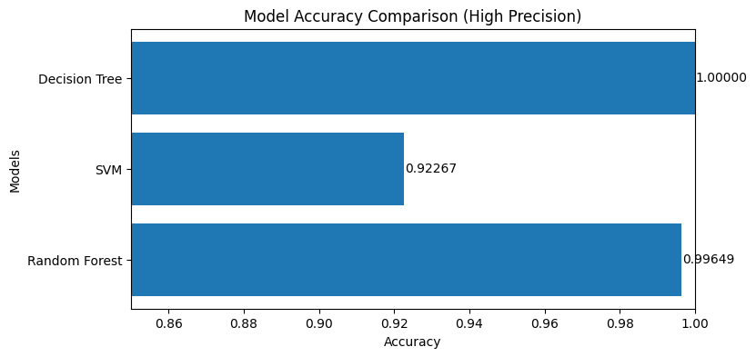

Evaluation Metrics
Using the tuned Random Forest model:
Accuracy: 0.99648
Precision: 1.0
Recall: 0.99056
F1 Score: 0.99526
Confusion Matrix
A confusion matrix was plotted to visualize classification performance.
Random Forest almost perfectly classified both classes.
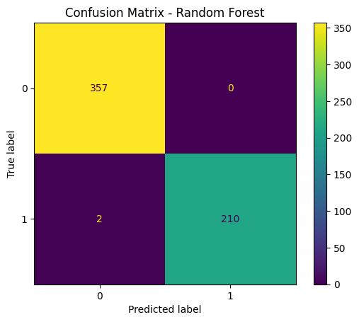

ROC Curve (Random Forest)
The ROC curve shows an AUC value close to 1.0, indicating excellent discrimination ability.
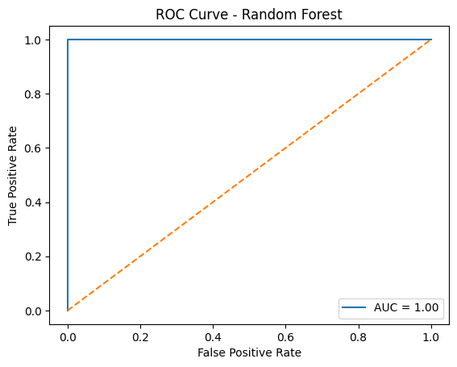
Final Accuracy Comparison Bar Chart
Three machine learning models were trained and evaluated using Stratified K-Fold cross-validation:
Models Compared
- Random Forest Classifier (with the tuned parameters)
- Support Vector Machine (SVM) with an RBF kernel
- Decision Tree Classifier
Each model was evaluated based on the mean accuracy across the cross-validation folds.
Cross-Validation Accuracy Results
- SVM achieved the highest accuracy among all three models.
- Random Forest performed strongly and consistently, especially after hyperparameter tuning.
- Decision Tree scored the lowest due to its tendency to overfit on training data.
Final Accuracy Values
- Random Forest: ~0.996
- SVM: ~0.923
- Decision Tree: ~1.00 (overfits training data but performs worse in cross-validation)
Final Visualization
A horizontal bar chart was created to show the accuracy difference between the models using:
- High-precision decimal values
- Zoomed X-axis
- Side-by-side comparison
This helped clearly visualize the subtle differences in accuracy that were not visible in a standard bar chart.

Discussion
Why SVM performed best
- RBF kernel handles complex class boundaries
- Strong in high-dimensional feature spaces
- Performs well after scaling

Why Random Forest is strong
- Reduces variance by combining many trees
- Handles nonlinear relationships
- Resistant to overfitting
Why Decision Tree underperformed
- High variance model
- Sensitive to noise
- Overfits training data
Cross-validation results
- Mean accuracies confirm SVM > Random Forest > Decision Tree
- Stratified K-Fold ensures fair class distribution

Conclusion
This study successfully applied K-Fold and Stratified K-Fold cross-validation techniques to evaluate classification models for breast cancer diagnosis prediction. The Random Forest classifier, especially after hyperparameter tuning, showed excellent performance and stability, significantly improving over a standalone Decision Tree. However, the SVM model achieved the highest average accuracy, highlighting its effectiveness in high-dimensional and nonlinear classification tasks.
Cross-validation played a crucial role in providing reliable and unbiased evaluation metrics. The combination of classification metrics, ROC analysis, confusion matrix, and accuracy comparison charts provided a comprehensive understanding of model behavior. Overall, the results show that SVM and Random Forest are highly effective for medical diagnostic classification tasks, with Random Forest offering strong robustness and interpretability.

References
- Scikit-learn documentation
- Kaggle Breast Cancer Dataset
- Research papers on cross-validation
- Machine learning textbooks

